RESUME
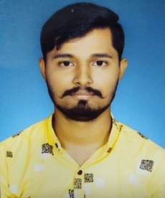

RIDDHISH ASHE
Hand phone: 8260636355
Email: riddhishashe20@gmail.com

PROFESSIONAL SYNOPSIS

- Good people skills with ability to communicate effectively and build long lasting/mutually beneficial relationships.

- Self-motivated and an effective communicator, social, innovative, with a flexible mindset and good interpersonal skills.

CAREER OBJECTIVE

To work in a challenging environment where, I can contribute towards the organizational growth and
develop myself as a professional by achieving the goals of the organization .

ACADEMIC CREDENTIALS

 
Education | Institution | Year | % or cgpa
B.Tech ( EEE ) | Srinix College Of Engineering , Balasore | 2021 | 7.36 cgpa
+2 Science | Balangi Jr. College , Balasore | 2017 | 52 %
Matriculation | Town High School , Balasore | 2015 | 77.66 %

TECHNICAL SKILLS

Computer : PGDCA & TALLY 9.0 from JMS Computer Academy

EXPERIENCE

TPNODL | As Intern | Feb-March 2021
CSC , Digital Seva | CCO | May 2022-June 2024
BCET, Balasore | Office Asst. ( Establishment Sec) | June 2024 -Continuing

STRENGTHS

- Good Communication Skills
- Positive Attitude
- Hard Working
- Quick Learning

HOBBIES

- Singing
- Reading Books
- Writing Story
- Crafting
- Traveling

PERSONAL DETAILS

Date of Birth 10 March 2000
Language English, Hindi, Odia, Bengali
Marital Status Single
Present Address S/O: Ramesh Ashe & Bedalata Ashe, AT: Manikhamb, PO: Motiganj,
DIST: Balasore, Odisha

I do hereby declare that all the above statements are true & correct to the best of my knowledge and belief.

Date:

Place: Balasore

